COLUMBIA RIVER ESTUARY RM&E PROJECT
- PROJECT INFORMATION
P2 Identifier | 123452
Project Manager (PM) | Mike Turaski (NWP, 503-808-4704)
Technical Lead (TL) | Ida Royer (NWP, 503-808-xxxx)
Biologist/Coordination

- PURPOSE
The purpose of this project is to conduct monitoring and evaluation in support of the Corps’ and BPA’s commitments per the FCRPS BiOp. A secondary purpose is to synthesize information and inform adaptive management of the Corps/BPA Columbia Estuary Ecosystem Restoration Program.

- BACKGROUND

Monitoring and evaluation are integral parts of the overall Corps/BPA estuary habitat program. The 2008 FCRPS BiOp included multiple specific RM&E tasks, to enable meaningful evaluation of estuary habitat restoration projects, improve design and implementation of future projects, and measure overall program implementation. These included: defining the ecological importance of tidal-freshwater habitats for juvenile salmon, identifying and describing reference sites, developing a method for assessing cumulative effects of restoration actions, and monitoring the effectiveness of completed restoration projects. Corps funding is complemented by BPA funding for less-intensive monitoring and RM&E activities in the Columbia River plume.

- STATUS & ISSUES
- Site-scale and landscape-scale impacts of restoration projects (i.e., direct and indirect effects) are being evaluated through the Action Effectiveness Monitoring and Research (AEMR) project. Field work is complete and the final report will be completed in May 2018.
- In March 2018, a Synthesis Memo will be completed. This memo will compile information about restoration projects completed between 2012 and 2018, summarize results of site scale action effectiveness monitoring, assess overall landscape/habitat connectivity, quantify the prey base for juvenile salmon across the estuary, evaluate the cumulative effect of restoration actions, and identify key uncertainties.
- SCHEDULE & COST

YEAR | COST | MAJOR ACTIVITIES
FY17  Actual Obligation | $2,247,107 | Ongoing work for AEMR and 2018 Synthesis Memo.
FY18  PBUD | $800,000 | Complete AEMR and 2018 Synthesis Memo.

- PHOTOS & DRAWINGS
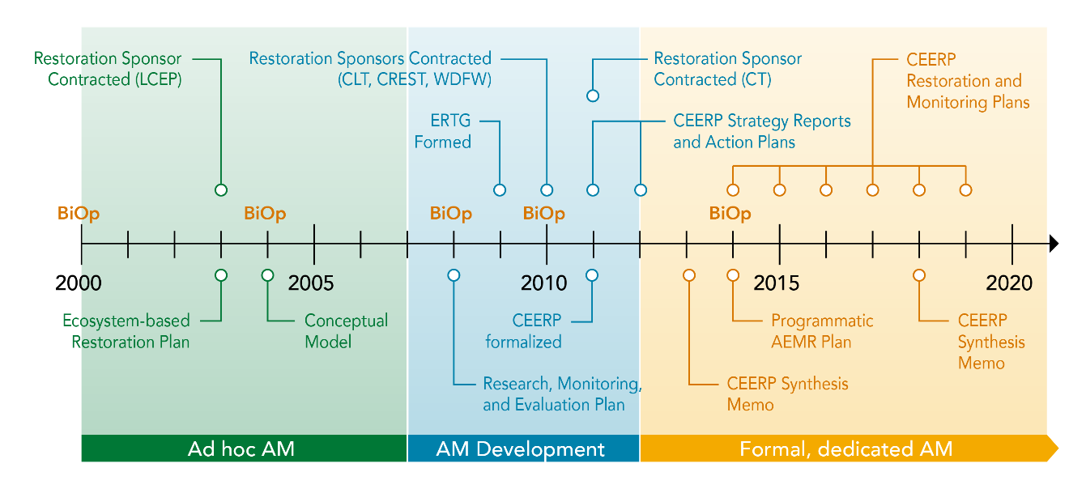
Summary timeline of BiOps, RM&E activities, and development of the CEERP program, from Ebberts et al., in press.

